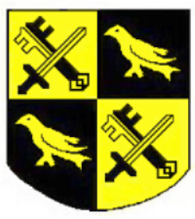
HELLINGLY RUGBY FOOTBALL CLUB C.I.C.
Lower Horsebridge, Hailsham, East Sussex. BN27 4DJ

CODE OF CONDUCT – MINIS AND JUNIORS

As a junior member of Hellingly Rugby Football Club (the Club) you are expected to abide by the following code of conduct that is designed to promote the elements of enjoyment and satisfaction and to ensure that certain standards of fair play and conduct that should be maintained at all times:
- Play because you want to.
- Be attentive.
- Recognise good play within your team.
- Take training sessions seriously.
- Play to the rules.
- Never abuse another team member.
- Do not argue with the coach or referees.
- Recognise the effort by those coaching you.
- Feel confident in being able to discuss your rugby concerns with your coach.
- Understand commitment to your team members.
- Be a sportsperson win or lose.
- Treat players as you would wish to be treated.
- Play with and for your teammates.

- Members should keep to agreed timings for training, matches and competitions or inform their coach or team manager if they are unable to attend or are going to be late.
- Junior members are not allowed to smoke, consume alcohol or drugs of any kind on club premises or whilst representing the club.

